

NASTech Data Collection System

User
Guide

Version 4.00
The software described in this document is furnished under a license agreement or nondisclosure agreement. The software may be used or copied only in accordance with the terms of the agreement. It is against the law to copy the software on any medium except as specifically allowed in the license or nondisclosure agreement. No part of this manual may be reproduced or transmitted in any form or by any means, electronic or mechanical, including photocopying and recording for any purpose without the express written permission of NASTech.

NASTech, Inc. reserves the right to make changes to this document and the software described herein at any time and without notice.

Copyright © 1993 - 2007 NASTech, Inc. All Rights Reserved.
NASTech, Inc.
4505 Manor Way
Flower Mound, TX
(888) 9-NASTECH

IBM is a registered trademark of International Business Machines Corporation.
Microsoft, MS, and MS-DOS are registered trademarks of Microsoft Corporation.
Windows is a trademark of Microsoft Corporation.
Pentium is a registered trademark of Intel Corporation.
TIM1B, TNET, TIM2B, TT5, are all trademarks of Computerwise Corporation.
UPS is a trademark of UPS Corporation.
Primac is a trademark of Vercom Systems Inc.
Table of Contents

Chapter 1 Introduction 1
System Features 1
Administrative Features 1
Shop-floor Hardware Features 2
Operational Features 2
Minimum System Requirements 2
Chapter 2 Software Installation 1
Initial Installation 1
Updating from DOS Version 3.16 2
Prepare Primac Computer 2
Prepare Windows Computer 3
Connect Windows Computer 3
Back-up DOS computer 4
Restore to Windows computer 4
Final Steps 4
Initialization File 5
Constants Section 5
Host Section 6
Network Section 6
Files Section 7
Chapter 3 Hardware Installation 1
Stand Alone Configuration 1
Tandem Configuration 2
Basic Shop-Floor Cabling 4
Optional Equipment 5
Chapter 4 Main Screen 1
Chapter 5 System File Maintenance 1
Transaction Maintenance 2
Prompt Message Maintenance 4
Error Message Maintenance 7
Station Maintenance 8
Function Key Maintenance 12
Function Key Download 13
Function Key Interpretation 13
TT9 Key Data Maintenance 15
Chapter 6 Master File Maintenance 1
Employee Maintenance 3
Division Maintenance 4
Department Maintenance 5
Cost Center Maintenance 6
Operation Maintenance 7
Cost Center / Operation Maintenance 9
Job Maintenance 10
Inventory Maintenance 11
Spoilage Maintenance 12
Prompt Maintenance 13
Employee Log Maintenance 14
Cost Center Log File 15
Chapter 7 Station Simulator 1
Simulator Operation 1
Chapter 8 Station Monitor 1
Monitor Operation 1
Chapter 9 Communications Monitor 1
Monitor Operation 1
Chapter 10 System Status Inquiry 1
Chapter 11 Transaction Definition 1
Overview 1
Sign-On (1) 3
Labor Entry (2) 5
Material Usage (3) 9
Return from Lunch (4) 13
Idle Time (5) 15
Start Concurrent (6) 17
Sign-Off (7) 19
Start Operation (8) 21
Review Transaction (R) 23
Print Shift Summary (P) 25
Appendix A Initialization File 1
Appendix B Keyboard Techniques 1
Record Selection 1
Field Editing 1
Appendix C Station Set-up 1
Operating Characteristics 1
Model TT4A 1
Model TT5A 2
Model TT5B 3
Model TT6 4
Model TT6A 5
Model TT9 6
Function Key Definition 7
Appendix D Tandem Switching 1
To Slave PC 1
Back to Master PC 1
Appendix E Trouble-Shooting Guide 1
System Installation 1
System Start-up 1
Shop-floor Network Connection 1
Host Communications 3
Master File Download 3
Appendix F Cable Diagrams 1
Modular Cable 1
Appendix G ASCII Conversion Chart 1

Chapter 1 Introduction
The NASTech Data Collection system (NDC-Plus) is a comprehensive system designed to provide both small and large businesses with a simple and cost effective method of capturing Time & Attendance and Work-in-Progress data directly from the shop floor. Many years of experience have gone into the design and development of this system. Simplicity, flexibility and high availability were the main criteria under which the software was developed.

We at NASTech are committed to designing and developing the highest quality software possible and are confident that you will enjoy working with NDC-Plus. We look forward to working with you and wish you every success in the future.

System Features

Administrative Features
- Unattended operation.
- User definable transaction types (up to 99).
- User definable prompt messages (up to 99).
- User definable prompt response edit criteria.
- Store and forward operation
- User definable master files (up to 20).
- Master file inquiry and optional maintenance.
- Built-in transaction test facility.
- Real-time shop-floor station monitoring.
- Host interface test and monitoring facility.
- Automatic download of master files during operation.
- Real-time upload of transactions to host computer.
- Automatic restart after power outage.
- Stations may be added or deleted during system operation.
- Sophisticated fail-safe capabilities.

Shop-floor Hardware Features
- Up to 250 shop-floor stations per plant.
- Up to 250 plants per system.
- Flexible configurations using modular cabling.
- Multiple shop-floor station types.
- Microsoft Windows station emulation.
- Barcode wand, scanner and slot reader support.
- Magnetic stripe reader support.
- Counter, tachometer and scale support.
- Barcode printer support.

Operational Features
- User definable on-line help messages.
- Bi-lingual prompt, help and error messages.
- Type ahead using separator.
- Correct previous entry within transaction.
- Cancel transaction at any point.
- Optional automatic transaction cancellation based on inactivity.
- Review previously entered transaction.
- Automatically interprets different barcode types.

Minimum System Requirements
- Pentium Computer with Windows-2000 or Windows XP.
- At least 128 MB of RAM.
- At least 100 MB of disk space.
- CD-ROM drive.
- Network adaptor.
- Floppy drive (1.44 MB).
- At least 1 serial port.
- ComputerWise TNET Controller (TIM1B).
- ComputerWise TLD2 Line Drivers if more than 4 ports used on TNET.
- Un-interruptible Power Supply recommended.

Chapter 2 Software Installation

Initial Installation
NDC-Plus is installed onto your hard disk (drive C) using a special installation program. This program may also be used to install future updates of the software as they become available.

- Insert the installation diskette in the appropriate floppy drive.
- Remove diskettes from floppy drives not in use.
- At the MS-DOS prompt, execute the installation program as follows:
- If you are using drive A, type a:install and press ENTER.
- If you are using drive B, type b:install and press ENTER.
- Select the install option by pressing the F1 key. You will be asked to name the directory into which you would like to install the software. The default directory is NDC_PLUS.
- Enter Y and ENTER to continue with the installation. You may enter N and ENTER to discontinue the installation process.
- The installation will only take a few minutes to complete. You will be kept abreast of the progress being made throughout the process. You may abort the installation at any time by pressing ESCAPE.

Once the installation is complete, you will need to check the CONFIG.SYS and AUTOEXEC.BAT files on your system. The MS-DOS EDIT command may be used to view and/or modify these files. If any changes are made to either of these files, it will be necessary to re-boot your system before proceeding.

Updating from DOS Version 3.16

Prepare Primac Computer
- Create a TELNETBP file in CBA account. (CREATE.FILE DIR TELNETBP)
- Download TELNETBP.zip from the following link: http://www.nastechinc.com/SUPPORT/NDCSupport/Upgrade/TELNETBP.zip
- Un-zip the telnet programs and store them in TELNETBP.
- Compile all the telnet programs using PBASIC.
- Create a user, password and .profile to log to TCL in JCS account or to main directory if running Rev 11 or later.
- Modify LOGIN record in the VOC file to invoke the TELNET.SERVER program. The user ID in line (a) should match the user ID in Dataload.ini.
- IF %1 = "username" GO 600
- GOTO 700
- 600 C
- HTELNET.SERVER
- P
- HBYE
- P
- 700 C
- Test by logging on to the new user created. No questions should be asked other than the password. If everything is OK, you will see a question mark. Typing END should log you off. (The program running has ECHO turned off, so you will not see what you type)
- Access the Download Maintenance screen in the Shop Floor menu. Create a DOWNLOAD record with the network ID equal to 250 minus the company number. For example: if your company number is 003 then the network ID will be 247.

Prepare Windows Computer
- Create a user, give the user Administrative rights.
- Update the date and time format on the PC. Control Panel - Regional Options. For Time use HH:mm:ss, for Date use MM/dd/yyyy.
- Create an NDC_PLUS directory in the C:\ directory.
- Create an INSTALL directory in the C:\NDC_PLUS directory.
- Download NDCWin.zip from the following link: http://www.nastechinc.com/SUPPORT/NDCSupport/Upgrade/NDCWin.zip
- Un-zip NDCWin.zip and save its contents to the INSTALL directory.
- Execute Setup.exe from the INSTALL directory and follow the onscreen instructions.
- Do not run the application at this time.
- Take away Administrative rights for the user. Log off, and log back on.
- Edit the C:\NDC_PLUS\DataLoad.ini file:
- Add the IP-Address for connection to Primac computer.
- Define the User ID, Password, Company Number and Division Number.
- Change the download criteria (day of the week, time of day, time interval) to match the download criteria specified on the Primac download maintenance screen.

Connect Windows Computer
- Place the computer where it will permanently reside.
- Using standard modem cable (9-pin female to 25-pin male), connect the TNET Controller to the serial port.
- Using standard Ethernet cable, connect the computer to the network.
- From the Start/Run command, type TELNET followed by a space, followed by the IP address to test the connection.

Back-up DOS computer
- Format 5 diskettes and label them “1”,”2”, “3”, “4”, and “Update”.
- Download Update.zip from the following link: http://www.nastechinc.com/SUPPORT/NDCSupport/Upgrade/Update.zip
- Un-zip Update.zip, and save its contents to the “Update” diskette.
- Wait until you can afford to shut down your system for at least ½ hour.
- Insure that all shop-floor transactions have been uploaded to Primac.
- Terminate shop-floor system.
- Insert “Update” diskette in floppy drive.
- From the A:\ prompt, type DOSUPD followed by the Enter key.
- Insert diskettes when prompted, wait for the floppy drive light to turn off before ejecting any diskette. You will be notified when the back-up is complete.

Restore to Windows computer
- Insert “Update” diskette in floppy drive.
- Browse to the A: drive and excecute WINUPD.BAT.
- Insert diskettes when prompted, wait for the floppy drive light to turn off before ejecting any diskette. You will be notified when the restore is complete.

Final Steps
- Execute NDC-Plus from desktop. The system will convert the old NDC.INI file to the new format and terminate automatically.
- Edit the NDC.INI file:
- Add the IP-Address, Username and Password used for connection to the Primac computer.
- Change the Port number in Network section of the file to match the Serial Port the TNET controller is physically connected to.
- Move the modular cables from the existing TLD2 to the TNET controller. If there are more than 4 cables, insert them into the TLD2, then connect the TLD2 to the TNET controller with a modular cable.
- Execute NDC-Plus from desktop.
- Enter your security code.
- Execute DataLoad from the desktop, and click Continue. If you get an error, look at the Dataload.txt file in the C:/NDCPlus directory. If you cannot ascertain what the problem is, please send the text file to support@nastechinc.com before contacting us.

Initialization File
After installing NDC-Plus, the NDC.INI file contains default values for your configuration. The parameters are divided into four sections as described below. See Appendix A for a listing of the file as initially installed. Upper and lower case may be used as desired with additional spacing for readability since all characters are converted to lower case and imbedded spaces are discarded prior to evaluation. The following describes each parameter.

Constants Section
Parameter | Default | Description
AbortTimer | 60 | Specifies the number of seconds to wait for a user to respond to a prompt before the transaction is canceled.
 |  | (0 = no time-out)
Beeper | on | Specifies how the shop-floor station beeper is used.
 |  | (on = beep once for prompt, twice for error; off = no beep; error = beep for error only)
MsgErrorType | 1 | Specifies the type of error checking to be performed when transmitting data to the host computer.
 |  | (1 = transmit data length; 2 = transmit hash total)
SysJrnlPath |  | Specifies the location of the remote journal file when utilizing the tandem configuration defined in the following chapter. The actual mapping of directories on the network is a function of the peer to peer networking software being utilized.
 |  | Example: F:\NDC_PLUS
Printer n |  | Defines the printers available for use in printing the employee’s time sheet. “n” is used on the Station Maintenance screen to define the printer to be used when a print request in initiated.
Example: Printer 1 = “\\PrintServer\Hp LaserJet 4 Plus"
Printer 2 = "\\PrintServer\Hp DeskJet 970Cse"
PageLines(n) | 66 | Specifies the number of lines which can fit on the printed output page. Based on the length of the paper used and the settings of the printer. When multiple printers are available and page lines differ, specify “n” to define the lines available for each printer. If “n” is not specified, the line count refers to all available printers.  Example: PageLines1 = 48  PageLines2 = 66
F1 - F8 |  | Function key values for station simulator and those shop-floor stations which support function keys. The number of characters which may be stored by each function key depends on the station type and model. The character "<" is used to store a <CR>. The number of characters which may be stored may be limited on some older shop-floor stations. A system maintenance feature is available to define function keys by station (see chapter 5).
UserParam1 - 8 |  | Up to 16 character string as defined and used by the user exits. See the NDC.INI delivered with your most recent update for specific details.

Host Section
Parameter | Default | Description
Mode | primary | Specifies the operating mode of the system. This parameter must be set to "secondary" on the stand-by system if present. Transactions sent to the host from the primary system are marked with a “P” and those from the secondary system are marked with an “S”. This allows the host system to identify the source of each transaction. This parameter may be eliminated when utilizing the tandem configuration.
 |  | (primary, secondary)

Network Section
Parameter | Default | Description
Port | 2 | Specifies the PC serial port to be connected to the shop-floor network.
 |  | (1 or 2)
Speed | 9600 | Specifies the baud rate to be used to communicate over the shop-floor network.
 |  | (2400, 4800, 9600, 19200)
Parity | none | Specifies the parity to be used to communicate over the shop-floor network.
 |  | (odd, even, none)
Stopbits | 1 | Specifies the number of stop bits to be used when sending data over the shop-floor network.
 |  | (1 or 2)
StationType | TT5 | Specifies the default station type when individual stations are not defined using the Station Definition Maintenance function.
 |  | (TT4, TT5, TT6, TT9)

Files Section
Parameter | Default | Description
FileName |  | Specifies the DOS file name without the extension
FileDesc |  | Specifies the full name of the file.
 |  | (up to 20 characters)
KeyLength |  | The maximum length of the record key.
 |  | (1 <= n <= 16)
RecordLength |  | The maximum length of the data including field delimiters.
 |  | (KeyLength <= n <= 512).
Update | no | Specifies whether the file may be updated using the file maintenance function.
 |  | (yes = allow update; no = inquiry only)
Journal | yes | Specifies whether changes to the file are to be made on the stand-by system if present.
 |  | (yes = update backup system; no = do not update)

this page intentionally left blank

Chapter 3 Hardware Installation
Two hardware configurations are available depending on the level of backup desired. It is highly recommended that a UPS system be installed for all configurations. The UPS system should be capable of sustaining power to the computer(s) for at least a couple of minutes since NDC-Plus ensures that all data is written to the hard disk every minute. When power is restored, the system will re-boot and NDC-Plus will resume operation automatically. Any transactions which were in progress when the power failure occurred must be re-entered.

Stand Alone Configuration
This configuration provides no backup facility. Failure of any critical component requires that a new system be loaded with all necessary software and the master files be reloaded before operation may be resumed. Employees must revert to manual time-keeping until the recovery procedure is completed.
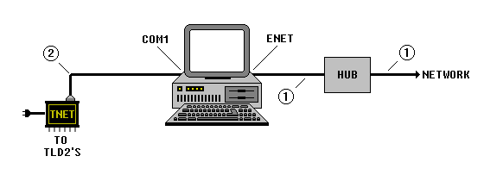
 Standard Ethernet cable.
 Standard RS-232 modem cable. Maximum length is 50 feet. Male connector required on TNET end. Connector on P/C end of cable is a 25-pin or 9-pin female depending on COM1 configuration.

Tandem Configuration
This configuration provides a hot stand-by facility. Both systems execute the NDC-Plus software and are networked together. One system assumes the roll of MASTER and the other SLAVE. This is determined by the system based on whether or not the TNET controller is connected to the associated computer.

Updates by the MASTER to system files, and those master files marked for journalization, are replicated by the SLAVE system such that the systems remain synchronized at all times. The system clocks are also synchronized automatically. Should anything happen to the MASTER system, the switches can be manually thrown and the SLAVE system takes over. At this point, the systems automatically reverse rolls of MASTER and SLAVE.

As with other types of recovery, transactions in process when the active system failed, must be re-entered.

A facility is also available to force synchronization of the two systems. This may be necessary when a new SLAVE system is installed or a SLAVE system is placed back on line after an extended period of time. This facility may be used whenever synchronization is questionable. To force syncronization of Master and Slave, click the Syncronize Files button on the main screen.

When running in Tandem configuration, DO NOT run DataLoad on the Slave computer.

As with any windows network, this configuration requires that an ethernet card be installed on both computers. This configuration also requires that the NDC_PLUS directory is shared on both computers, and that each user has read/write access to the other computer.

The wiring diagram for this configuration appears on the next page.
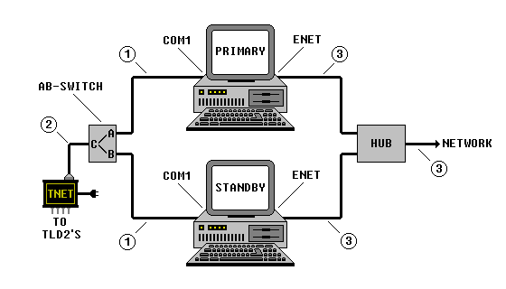
① Standard RS-232 modem cable. Maximum length is 50 feet. Male connector required on TNET end. Connector on P/C end of cable is a 25-pin or 9-pin female depending on COM1 configuration.
② Standard RS-232 DB-25 modem cable. Maximum length is 50 feet. Male connector required on both ends.
③ Standard Ethernet cable.
AB-Switch - Standard 25-pin switch. All female connectors.

Basic Shop-Floor Cabling
The following diagram illustrates the basic cabling requirements of the shop-floor data collection system. Unshielded twisted pair (UTP) cable is recommended for all modular cabling as it provides protection against electrical interference. It is also recommended that a suitable number of spare devices be kept on hand at all times. Appendix C describes the procedure required to set up the shop-floor stations. See Appendix E for cable diagrams.

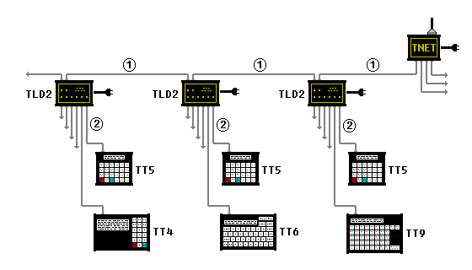

 Modular cable. Maximum length is 2,000 feet.
 Modular cable. Maximum length is 100 feet if station is powered by TLD2. By supplying power to individual shop-floor stations, the distance may be extended to 2,000 feet.

Optional Equipment
The following diagram illustrates various optional equipment which may be connected to the shop-floor network. Consult with your vendor to determine the make and model of the counters, scales and printers currently supported and their specific cabling requirements.
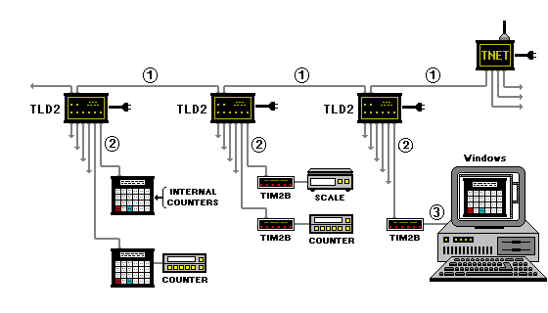

 Modular cable. Maximum length is 2,000 feet.
 Modular cable. Maximum length is 100 feet if station is powered by TLD2. By supplying power to the shop-floor station, the distance may be extended to 2,000 feet.
 Standard RS-232 modem cable. Maximum length is 50 feet. Male connector required on TIM2B end. Connector on P/C end is a 25-pin or 9-pin female depending on serial port used.

this page intentionally left blank

Chapter 4 Main Screen
After executing the system by Double-Clicking the desktop icon, and by entering the required security code, the following screen appears. To terminate, ensure that the network is disconnected and then press F12.

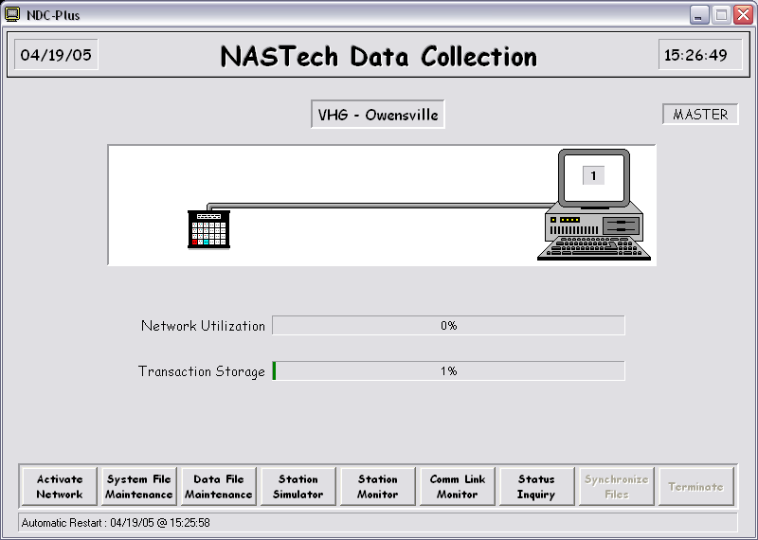

The Main Screen contains five separate areas as follows:

The Header section – This section contains the current date and time.

The Graphics section – This section indicates when the shop-floor network is active (inactivity is indicated by a break in the cable). Shop-floor usage is represented by a worker who makes an appearance each time a transaction is completed.
The Statistical section – This section contains various statistics in graphical form as follows:
- Network Utilization - number of stations connected as a percentage of the maximum number of stations licensed.
- Transaction Storage - number of transactions awaiting transmission as a percentage of the total transaction storage made available.
- The Menu section – This section contains 8 buttons to invoke various functions as follows:
- Activate Network - Used to activate and deactivate the shop-floor network.
- System File Maintenance - Used to activate the system file maintenance function.
- Data File Mainteneance - Used to activate the master file maintenance function.
- Station Simulator - Used to activate the station simulation sub-screen.
- Station Monitor - Used to activate the station monitor sub-screen.
- Comm Link Monitor - Used to activate the host interface monitor sub-screen.
- Status Inquiry - Used to display various system level status information.
- Synchronize Files - Used to synchronize a stand-by system with that of its primary system when using the tandem configuration.
The Message section - This section is used to display system level help messages and error messages.

Chapter 5 System File Maintenance
The system master files represent one of the many methods used by NDC-Plus to provide the system with its unique flexibility. Appendix B describes how to view and edit data on the file maintenance screens. The following summarizes the functionality provided by these files:

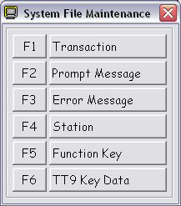

- Transaction - Defines the order in which the messages are presented to the user for input.
- Prompt Message - Defines the prompt messages presented to the user and the edit criteria for the input data. The prompt messages and help messages may be defined in two languages.
- Error Message - Defines the error messages which are displayed to the user when data is entered in error. The error messages may be defined in two languages.
- Station - Defines the location and type of each station on the network. Also, the location and association of other devices such as counters, scales and barcode printers.
- Function Key - Defines the settings of each of eight function keys by station. The datadefined may be downloaded or selected upon receipt of and appropriate command from the station.
- TT9 Key Data - Defines the settings of each of the keys on a TT9 station. Each key may contain up to 16 characters of alphanumeric data for each of 3 overlays.

Transaction Maintenance
This screen is used to define the various transactions which may be used on the shop-floor stations. A transaction represents a series of prompt messages which are to appear on the shop-floor station.

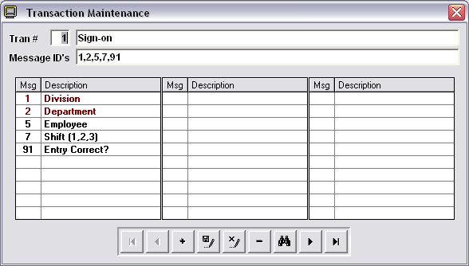

The fields on the above screen are defined as follows:

Transaction Number Any number between 1 and 99. Transaction numbers 90 through 99 are reserved for system level functions.
Message ID’s The prompt messages, (separated by commas), which are to be presented to the employee at the shop-floor station. A maximum of thirty message numbers may be entered.
The message ID and associated prompt messages are displayed in the bottom half of the screen. These are displayed upon initial display of a record or when modifying the message sequence and then pressing the ENTER key or the TAB key.
A prompt message displayed in RED indicates that the Optional field of the prompt message is marked with an "S" and therefore will be skipped.
A prompt message displayed in GREEN indicates that the Optional field of the prompt message is marked with an "S" and therefore will be skipped, however, the default value will be used as if it had been entered.

Prompt Message Maintenance
This screen is used to define the various prompts which may appear on the shop-floor stations. The order in which the messages appear is defined by the transaction definition screen previously described.

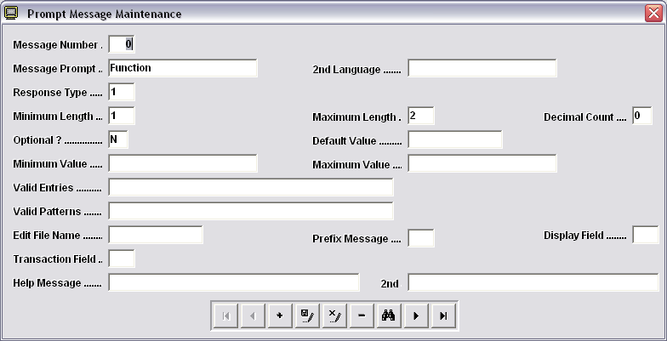

The fields on the above screen are defined as follows:

Message Number Any number between 0 and 99. Message number 0 is used to define the initial prompt message on the shop-floor station.
Message Prompt The prompt message in both primary and secondary languages, which is to appear on the shop-floor station. The secondary language is optional. The secondary language is used only when present and the secondary language type is specified on the Employee file.
2nd Language The prompt message in both primary and secondary languages, which is to appear on the shop-floor station. The secondary language is optional. The secondary language is used only when present and the secondary language type is specified on the Employee file.

Response Type The type of data which may be entered in response to the prompt.
1) alphanumeric
2) alphabetic
3) integer numeric
4) decimal numeric
5) date
6) time of day
7) reserved for future use
8) (Y)es or (N)o
20) modulo 10 check digit
Minimum Length The minimum number of characters which the user may enter. If the field is optional as defined below, the user may leave the field blank or enter the minimum number of characters specified here.
Maximum Length The maximum number of characters which the user may enter. If set to zero, the field is for display only and may not be modified.
Decimal Count The maximum number of digits which may be entered following the decimal point. Used for decimal type data only. The maximum field length must be large enough to allow for all digits and the decimal point.
Optional Specifies whether a response is optional or required. "Y" is used to indicate that the response is optional. "S" indicates that the prompt is to be skipped. “N” is the default and indicates that a response is required.
Default When a response is defined as being optional, the value specified here is used as the response when the user presses the ENTER key in response to the prompt message. If the optional field contains an "S", the prompt message is not displayed and the value is used as if it had been entered.
Minimum Value Specifies the minimum value which may be entered. Used for integer, decimal, date entries only. “DATE”, “DATE+n” and “DATE-n” may be used for date range checking where “DATE” represents the current date.
Maximum Value Specifies the maximum value which may be entered. Used for integer, decimal and date entries only. “DATE”, “DATE+n” and “DATE-n” may be used for date range checking where “DATE” represents the current date.
Valid Entries When the data type is alphanumeric, this entry defines the only entries which may be entered by the user. The valid entries are separated by commas. For numeric or decimal type fields, the values specified are in addition to any valid numeric data which may be entered.
Valid Patterns Specifies the sequence of numeric, alphabetic, alpha-numeric data and the position of any required constants. The pattern consists of an integer number followed by the letter N, A or X or a quote delimited character string. The integer defaults to a 1 if omitted and a 0 may be used to define a variable sequence of characters. Also, the quotes are optional except when omission may cause the pattern to be interpreted incorrectly. Example: 3N-3N-4N for telephone number, 0N.2N for a decimal number with fixed number of decimals, “0”5N for a six digit integer with a required leading zero.
Edit File The name of the file which is to be used to validate the user response.
Prefix Message If the key to the edit file is a combination of data elements, specify the message number whose response is to be concatenated to the beginning of the current response prior to validating the entry against the specified edit file.
Display Field When validating a response against a file, you may display one of the fields within the file on the shop-floor station for visual verification.
Trans Field Specifies the field number, within the transaction passed to the host computer, where the response is stored. This field is not required for standard prompt messages since the format of the transaction is controlled by the user exits supplied with the system.
Help Message The help message in both primary and secondary languages which is to appear on the shop-floor station when the user enters a "?" in response to the prompt message.

Error Message Maintenance
This screen is used to define the various errors which may occur during the transaction entry process at the shop-floor station. Error message numbers 1 through 50 are reserved for system level errors. Error message numbers 51 through 99 are reserved for use within the application specific user exits.

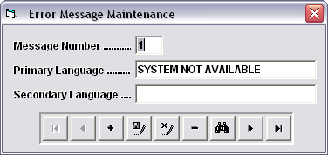

The fields on the above screen are defined as follows:

Message Number Any number between 1 and 99. Message numbers 1 through 50 are reserved for system use. Message numbers 51 through 99 are for application use.
Primary Language The error description in the primary language.
Secondary Language The error description in the secondary language. The secondary language is used only when present and the secondary language type is specified on the Employee file.

Station Maintenance

This screen is used to define the various shop-floor stations and to store related counter and tachometer information.

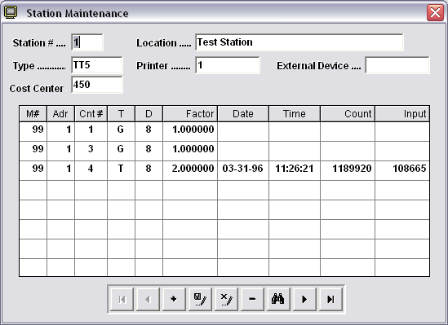

The fields on the above screen are defined as follows:

Station Number The number corresponding to the address set up for the shop-floor station being defined. Shop-floor stations should be addressed beginning at 1.
Location The physical location of the station being defined.
Station Type The type of shop-floor station being defined. The types currently available are:
1) TT4 - 8 line x 40 characters display.
2) TT5 - 2 line x 24 character display.
3) TT6 - 2 line x 40 character display, alphanumeric keyboard.
4) TT9 - 2 line x 40 character display with programmable keyboard.
5) TIM2B - RS232 interface device.
6) TSE - Station Emulator.
Printer Several printers may be made available to the NDC-Plus computer for printing the shift summary report described in chapter 11. This parameter defines which of the available printers is to be used to print the report when requested from this station. An asterisk should be used in conjunction with a station emulator. This will cause the report to be displayed on the emulator for subsequent printing.
External Device When the station contains an auxiliary port or the station type is a TIM2B, this field is used to define the RS232 device connected to the station or to the TIM2B. This can be a counter or a scale supported by the system.
Cost Center If the station is only used in conjunction with a specific cost center, you may enter the cost center ID here. If this is done, the system will not prompt for cost center when a transaction is entered from the station.
M# The message number which is to be satisfied by reading the specified counter. If the counter being read is not internal to this station, a similar entry will also appear on the specified station to store the counter values read. This field will contain a “**” to indicate that this has occurred.
Adr The station ID of the station or TIM2B containing the counters. If the counters are internal to a station other than the station being defined, the station so defined should not be used for transaction input.
Cnt # The counter to be read. The value entered here depends on the type of counter being used. Internal station counters are numbered 1 through 4. For external counters connected to a TIM2B, an optional device number may be specified. Example, 4-1 specifies that external Device #4 is to be interrogated and Counter #1 is to be read.
T Specifies the type of read to be performed, (G)ross count, (N)et count or (T)achometer reading. The net count is computed by subtracting the previous counter reading from the current value. Tachometer reading is only available if the external counter is so equipped.
D The number of digits of the counter readout to be used. Must not exceed the actual number of digits supported by the counter.
Factor The factor is used to convert between different units of measure. Example, if a counter is incremented 4 times for each rotation of a roller and the roller circumference is 57.35 inches, this can be converted to feet with a factor of 1.194792 or ( 57.35 ÷ 4 ÷ 12 ). The actual counter reading is multiplied by the factor to produce the count in the required unit of measure. The maximum result of the multiplication must not exceed 2,147,483,647.
Date Updated when a transaction is completed and contains the date that the counter was last read.
Time Updated when a transaction is completed and contains the time that the counter was last read.
Count Updated when a transaction is completed and contains the count at the time of the last reading. The value stored is the actual counter reading multiplied by the factor previously described.
Input Updated when a transaction is completed and contains the value used to satisfy the prompt message. For gross counter readings or tachometer readings, this value will be the same as the count field previously described.
Last Start Used to display the date and time that the tachometer reading changed from zero to some greater value. The accuracy of this information is dependent on how often the tachometer is read.
Last Stop Used to display the date and time that the tachometer reading changed to zero from some greater value. The accuracy of this information is dependent on how often the tachometer is read.

Function Key Maintenance
This screen is used to define the data associated with each function key of a specified station. The specified data may be downloaded to the station, or used as if it were entered at the station when the appropriate command is received from the station.

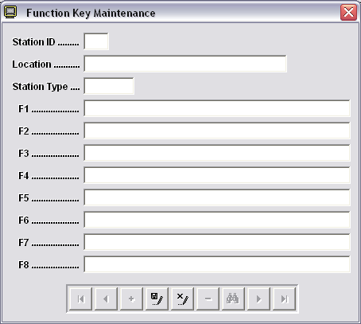

The fields on the above screen are defined as follows:

Station The number corresponding to the address set up for the shop-floor station being defined. This is the same number as that used when defining the station using the station maintenance facility described previously. To copy the function key settings from another station, enter the new station number followed by a hyphen and then by the number of the station to be copied.
Station 251 may be used to define the function keys for the Station Simulator (see chapter 7).
Location Location of station as defined on the Station Definition Maintenance screen.
Type Station type as defined on the Station Definition Maintenance screen.
Key Definition Up to 40 characters may be defined for each of the function keys. Multiple prompt message responses may be defined for each function key by utilizing the MsgSep character defined in the NDC.INI file. If the function key data is not enclosed in double quotes, the data will be downloaded to the function keys when requested. In this case, the character “<" is used to store a <CR>.

Function Key Download
If the function key data is NOT enclosed in double quotes, the data will be downloaded to the station when requested. In this case the “<“ is used to store a <CR> (see examples above for F7 and F8). Although it is more efficient to download data to the station function keys, the amount of data which may be downloaded is limited based upon the type and model of the station being used (see hardware manual for specific limitations).

To download the function keys, enter $F and press the ENTER key. The message F1-F8 LOADED is displayed upon successful completion of the download. Individual function keys may be downloaded by entering $F1 through $F8 for function keys 1 through 8 respectively.

Function keys must be loaded for each station on the network and for those stations subsequently added to the network. If the download is requested from a station whose function keys have not been defined using this facility, the function key data defined in the NDC.INI file is used for the download.

Function Key Interpretation
When function key data is enclosed in double quotes, the data is not downloaded to the station but is used by the system as if it were scanned or keyboard entered at the station. This occurs when the appropriate command is received from the station. The commands are $1 through $8 for function keys 1 through 8 respectively. These commands may be entered from the keyboard or scanned from bar-coded target sheets.

Additionally, commands may be downloaded to the function keys of the station by entering $F and pressing the ENTER key. The message F1-F8 LOADED is displayed upon successful completion of the download. Commands may be downloaded to individual function keys by entering $F1 through $F8 for function keys 1 through 8 respectively. If the data associated with the function key is delimited by double quotes, then $1<CR> is downloaded to function key 1, $2<CR> to function key 2 and so forth. If the associated data in NOT enclosed in double quotes, the actual data is downloaded to the function key as described above.

Function keys must be loaded for each station on the network and for those stations subsequently added to the network. It should be noted that this feature may not be supported by some older shop-floor stations since the function keys will only store 2 characters. If the download is requested from a station whose function keys have not been defined using this facility, the function key data defined in the NDC.INI file is used for the download.

TT9 Key Data Maintenance
This screen is used to define the various keys on the TT9 type shop-floor stations. The key settings of station 0 becomes the initial starting point for all other stations. Each station can have 3 different settings called overlays. Overlays could be used to define different key settings for different cost centers sharing a single TT9. Overlays are selected by transmitting “#n” where n is the requested overlay. If a single overlay is used, it is not necessary to define the “#n” keys.

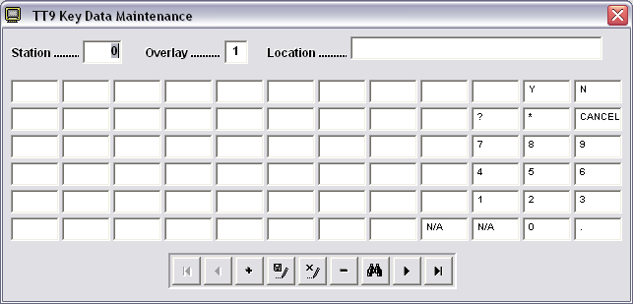

The fields on the above screen are defined as follows:

Station The number corresponding to the address set up for the TT9 shop-floor station being defined. This is the same number as that used when defining the station using the maintenance facility described previously. To copy the key settings from another station, enter the new station number followed by a hyphen and then by the number of the station to be copied. If this is not done, the settings of station 0 is copied to the new station being defined.
Overlay The TT9 keyboard may be programmed differently for each of three overlays. To view or modify the various keyboard definitions, press F1 for overlay 1, F2 for overlay 2 or F3 for overlay 3.
Key Contents Up to 16 characters may be programmed into each of the 72 keys for each of the three overlays.

Chapter 6 Master File Maintenance
The master data files are application specific files used mainly to edit data keyed by the operator and for displaying descriptive data for visual verification. Although the master file data may be key entered via the associated screens, the data is generally downloaded from the main system computer. A total of 20 files may be defined for this purpose. New files are added to the system by adding the necessary file definition lines to the NDC.INI file (see chapter 2). The screens used to display the data are defined using the editor and are stored in the SCREEN directory. If the screen definition file is not created, the screen by the name of GENERIC.SCN is used as a default. Appendix B describes how to view and edit data on the file maintenance screens. To exit from the current menu or screen press F12.

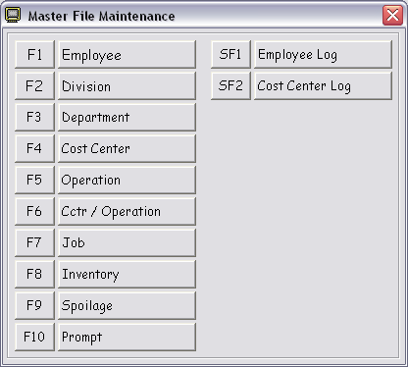

The following summarizes the functionality provided by these files.
This file is used to define the valid employees whose activities are to be recorded.
This file is used to define the various divisions within the plant.
This file is used to define the various departments within the plant. Since a department may perform work for more than one division, the division ID is used to prefix the department ID. Example, "0135" and "0235" defines department "35" as being valid for both divisions "01" and "02".
This file is used to define the various cost centers or work centers within the plant.
This file is used to define the various operations which may be performed within the company. The operations may be defined generically. Example, "SETU" defines the set-up code. This operation may be performed upon many different pieces of equipment within the plant.
This file is used to define the association between the valid operations and the cost centers upon which the operation may be used. The standard time required to perform the operation is defined at this level since the time required to set-up two different pieces of equipment may be different.
This file is used to define the various active jobs which may be worked upon within the plant.
This file is used to define the various inventory products which may be used within the plant.
This file is used to define the various spoilage codes which may be used within the company. These codes are used to categorize labor and material spoilage.
This file is used to define the various Additional Prompt messages which may be associated with a particular operation. Up to 10 prompts may be linked to each operation code and are presented on the shop-floor station in the order specified. This capability may not be available in all versions of PRIMAC.
This file is used by the system to keep track of each employee's status and last activity.
This file is used to store ending counter readings for each cost center. The counter reading may be used as the beginning counter reading for the next entry for the associated cost center. This capability may not be available in all versions of PRIMAC.

Employee Maintenance
This screen is used to define the valid employees whose time and/or activities are to be recorded.

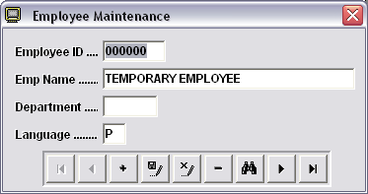

The fields on the above screen are defined as follows:

Employee ID Employee ID as defined in PRIMAC.
Emp Name Full name.
Department Home department (information only).
Language Specifies whether to communicate to the employee in the (P)rimary or (S)econdary language.

Division Maintenance
This screen is used to define the various divisions within the plant.

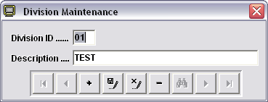

The fields on the above screen are defined as follows:

Division ID Division number assigned in PRIMAC.
Description Division description.

Department Maintenance
This screen is used to define the various departments within the plant. Since a department may perform work for more than one division, the division ID is used to prefix the department ID. Example, "0135" and "0235" defines department "35" as being valid for both divisions "01" and "02".

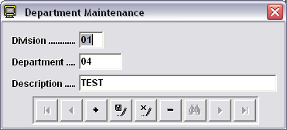

The fields on the above screen are defined as follows:

Division Division number assigned in PRIMAC.
Department ID Department number assigned in PRIMAC.
Description Department description.

Cost Center Maintenance
This screen is used to define the various cost centers or work centers within the plant.

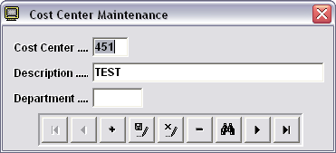

The fields on the above screen are defined as follows:

Cost Center Cost center number assigned in PRIMAC.
Description Cost center description.
Department Department to which the cost center is assigned.

Operation Maintenance
This screen is used to define the various operations which may be performed within the company. The operations may be defined generically. Example, "SETU" defines the set-up code. This operation may be performed upon many different pieces of equipment within the plant.

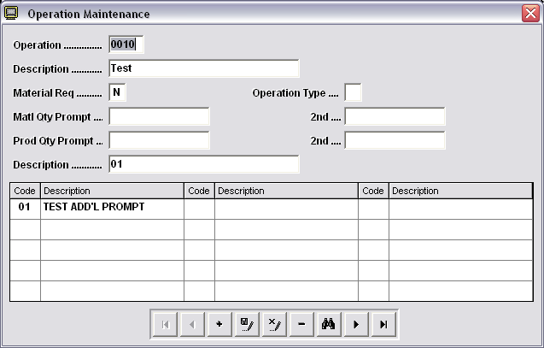

The fields on the above screen are defined as follows:

Operation Operation number assigned in PRIMAC.
Description Operation description.
Material Req'd Defines whether or not material must be entered in conjunction with the operation. If the field is blank, product information will be requested but entry will be optional.
Operation Type Indicates whether the operation is (N)on-chargeable.
Matl Qty Prompt The prompt message, in primary and secondary languages, to be used when requesting product information. If this field is blank, the prompt message defined within the transaction is used.
Prod Qty Prompt The prompt message, in primary and secondary languages, to be used when requesting run counts. If this field is blank, the prompt message defined within the transaction is used. This capability may not be available in all versions of PRIMAC.
Prompt Codes Defines the list of additional prompts to be displayed to the employee when a transaction is entered for this operation. The prompt codes are defined later in this chapter. It should be noted that this capability may not be available in all versions of PRIMAC.

Cost Center / Operation Maintenance
This file is used to define the association between the valid operations and the cost centers upon which the operation may be used. The standard time required to perform the operation is defined at this level since the time required to set-up two different pieces of equipment may be different.

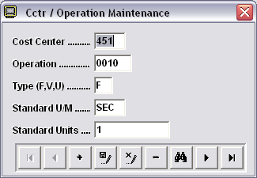

The fields on the above screen are defined as follows:

Cctr/Oper First 3 digits represent the cost center. Subsequent characters define the operation which is valid for the associated cost center. Valid operations for each cost center are defined in the PRIMAC cost center maintenance function.
Type Indicates whether the operation is of the (F)ixed, (V)ariable, or (U)nit type.
Standard U/M Specifies whether the production standard is specified in operations per hour (OPH), operations per minute (OPM) or number of seconds (SEC). OPM is not used by PRIMAC.
Standard Units The production standard.

Job Maintenance
This screen is used to define the various active jobs which may be worked upon within the plant.

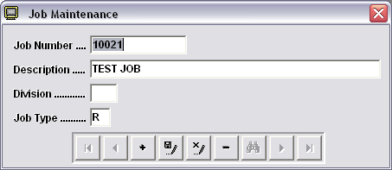

The fields on the above screen are defined as follows:

Job Number Job number assigned in PRIMAC.
Description Job Description assigned in PRIMAC.
Division Division to which the job has been assigned.
Job Type Indicates whether the job is a (R)egular, (N)on-chargeable, (C)hange order, or (S)poilage job.

Inventory Maintenance
This screen is used to define the various inventory products which may be used within the plant.

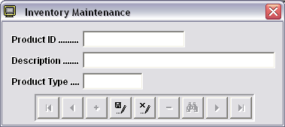

The fields on the above screen are defined as follows:

Product ID Inventory product number assigned in PRIMAC.
Description Product description.
Product Type Indicates whether the inventory product is regular (REGULAR), sheet paper (SHEET), roll stock (ROLL), roll label stock (LROLL) or paper coater (PCOAT).

Spoilage Maintenance
This screen is used to define the various spoilage codes which may be used within the company. These codes are used to categorize labor and material spoilage.

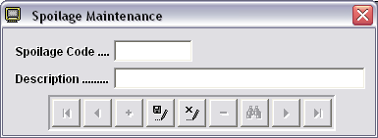

The fields on the above screen are defined as follows:

Spoilage Code Spoilage code assigned in PRIMAC.
Description Spoilage code description.

Prompt Maintenance
This screen is used to define the various prompt messages which may be associated with a particular operation being reported. Up to 10 prompts may be linked to each operation code. The prompt messages will be displayed on the shop-floor station in the order specified. This capability may not be available in all versions of PRIMAC.

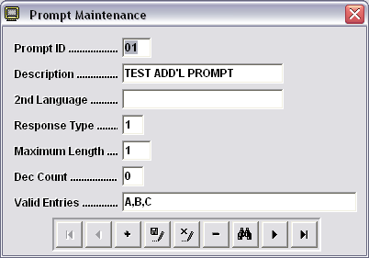

The fields on the above screen are defined as follows:

Prompt ID Prompt number assigned in PRIMAC.
Description Prompt description to be displayed on shop-floor station.
2nd Language The second language to be used. IE.. Spanish.
Response Type Used to validate the response. (1 = alphanumeric, 2 = alphabetic, 3 = numeric, 4 = decimal, 8 = Y/N).
Maximum Length Maximum length allowed for the response.
Dec Count Number of digits to follow decimal point for decimal type entries.
Valid Entries Specific valid entries separated by commas.Valid Patterns

Employee Log Maintenance
This screen is used by the system to keep track of each employee's last activity.

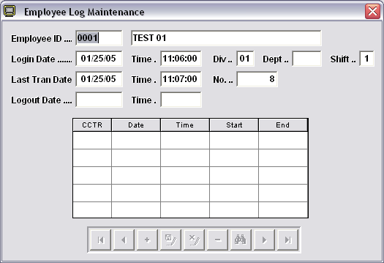

The fields on the above screen are defined as follows:

Employee ID Employee ID as defined in PRIMAC. The employee name is also displayed.
Login Date / Time Last time that the employee signed on to the system.
Division / Dept / Shift Division, department and shift entered for last sign-on.
Last Tran Date / Time Last time that the employee entered a transaction.
Last Tran Number The transaction number assigned by the system to the last transaction entered by the employee.
Logout Date / Time Last time that the employee entered a sign-off transaction. Blanks in these fields indicate that the employee is currently signed on.
Cost Center Activity When an employee is working multiple cost centers the Start Date, Time and Transaction number is stored for the each of five cost centers. The presence of the End transaction number indicates that work in the associated cost center has been completed.

Cost Center Log File
This screen is used to store various cost center related data for subsequent use by the system.

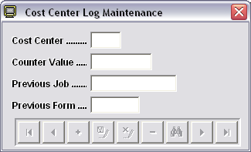

The fields on the above screen are defined as follows:

Cost Center Cost center number assigned in PRIMAC. The cost center description is also displayed.
Counter Value Contains the response to the previous prompt for ending counter reading.
Previous Job
Previoue Form

Other data elements may appear on this screen to meet the specific requirements of individual users of NDC-Plus. These additional elements may or may not be supported by the base system.

this page intentionally left blank

Chapter 7 Station Simulator
The Station Simulator is used to test the various transactions which may be entered by the employee on the shop floor. The station simulates the TT5, which is the most widely used station available. To exit from the simulator, press F12.

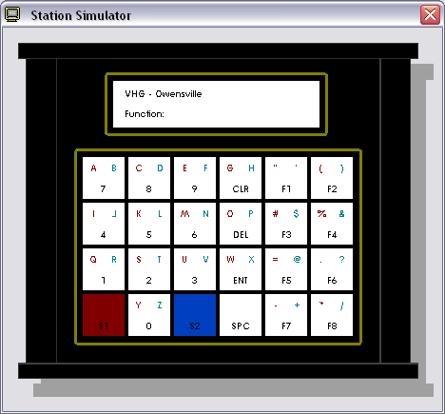

Simulator Operation
The simulator is operated by using the system keyboard. Entries made at the keyboard are displayed in the window as are the various prompt messages, validation messages and error messages. The function keys are operable and are defined using the Function Key Maintenance facility (see chapter 5). Station number 251 is used to reference the simulator. If this station is not defined, the function key values defined in the system initialization file (NDC.INI) are used.

this page intentionally left blank

Chapter 8 Station Monitor
The Station Monitor is used to view the operation of any of the stations on the shop-floor network. The station simulates the TT5, which is the most widely used station available. To exit from the monitor, press F12.

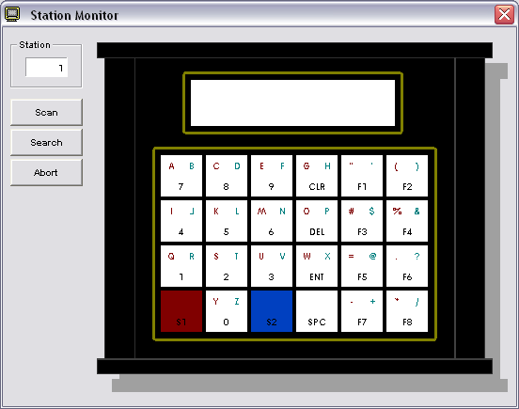

Monitor Operation
The monitor may be operated in one of two modes as follows:

Scan Mode In scan mode, the system interrogates each station on the network in sequence. When a station is found to be active, (transaction being entered), scanning stops on that station for viewing. Data keyed or wanded at the station is displayed in the station monitor display area. The scanning continues when the transaction is completed or the ENTER key is pressed on the system keyboard.

Seek Mode In seek mode, the system polls each station on the network in sequence. When a station is found to be on-line, polling is suspended. Data keyed or wanded at the station is displayed in the station monitor display area. The polling remains suspended until the ENTER key is pressed on the system keyboard.

In either mode, if a station has been left active, the active transaction may be terminated by selecting the ABORT button. This has the same effect as if the employee had pressed the CANCEL key on the shop-floor station. If the "AbortTimer" is specified in the initialization file (NDC.INI), stations left in an active state will be canceled automatically after the specified inactivity time.

Chapter 9 Communications Monitor
This screen is used to view data being transmitted to the host computer. Related error message are also displayed.

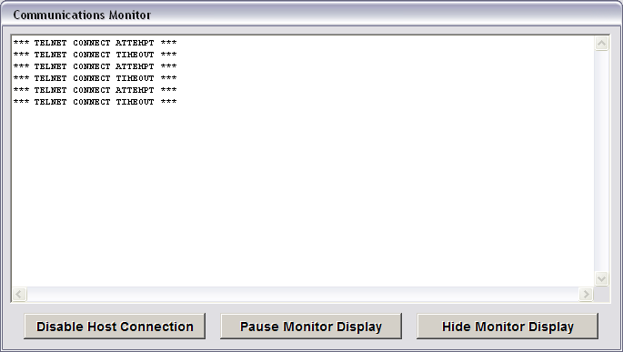

Monitor Operation
Disable Host Con Used to temporarily stop all communications to the host computer.
Pause Mon. Display Used to temporarily stop new messages from being displayed so that the displayed data can be read.
Hide Mon. Display Used to minimize the communications monitor..

this page intentionally left blank

Chapter 10 System Status Inquiry
This screen is used to view key system status information. The status information is dynamically updated as changes occur.

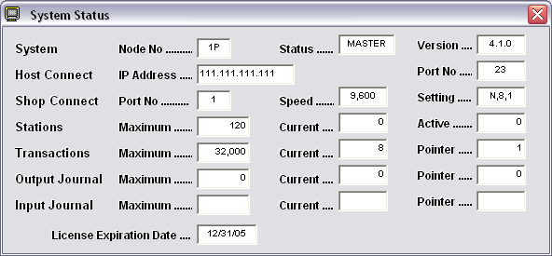

System | Address | System address as assigned by NASTech. A (P)rimary or (S)econdary suffix may be present as defined by the Mode parameter in the NDC.INI file.
 | Status | MASTER or SLAVE or UNKNOWN as determined by the TNET connection. Only the MASTER system can communicate with the host computer. When running a stand-alone system, the status may be forced to MASTER by specifying the /M option in the shortcut used to initiate the system.
 | Version | The version of the NASTech Data Collection Software being used.
Host Connect | IP Addr. | The IP address being used to communicate with the host computer. The host connection parameters are defined in the host section of the NDC.INI file.
 | Port No | The port number for the Telnet connection to the host computer.
Shop Connect | Port No | The port number being used to communicate with the shop-floor stations. The shop-floor connection parameters are defined in the network section of the NDC.INI file.
 | Speed | The data speed (baud rate) being used to communicate with the shop-floor stations.
 | Setting | The parity, number of data bits and the number of stop bits being used to communicate with the shop-floor stations.
Stations | Maximum | The maximum number of shop-floor stations which may be connected to the system.
 | Current | The number of stations currently connected to the system.
 | Active | The number of stations currently being utilized for entry of a transaction.
Transactions | Maximum | The number of transactions which may be stored by NDC-Plus while the host computer in not available.
 | Current | The number of transactions stored and awaiting transmission to the host computer. The system will not allow additional transactions to be entered when the current transaction count reaches the maximum allowed.
 | Pointer | The pointer to the next transaction available to the host computer.
Output Journal | Maximum | The number of journal entries which may be stored by this system when operating as the master in the tandem configuration.
 | Current | The number of journal entries stored by this system and waiting to be retrieved by the standby system. When the current count is zero, the tandem standby system is synchronized.
 | Pointer | The pointer to the next journal entry available to the tandem standby system.
Input Journal | Maximum | The number of journal entries which may be stored by the tandem system when it is operating as the master.
 | Current | The number of journal entries stored by the tandem master system and waiting to be retrieved. When the current count is zero, the systems are synchronized.
 | Pointer | The pointer to the next journal entry available on the tandem master system.

this page intentionally left blank

Chapter 11 Transaction Definition

Overview
The following section defines the workstation entry procedures for transactions being entered from the shop floor.

The transactions described are:
Sign-On (1) This transaction notifies the system that an employee has reported for work.
Labor Entry (2) This transaction is used to report the completion time for an operation. Materials used in the course of performing the specified operation may also be reported.
Material Usage (3) This transaction is used to report material usage.
Return from Lunch (4) This transaction notifies the system that an employee has returned to work after a non paid lunch break.
Idle Time (5) This transaction is used to report non-paid employee time. Paid idle time must be reported against a non-chargeable operation using the Labor Entry transaction.
Start Concurrent (6) This transaction is used to record concurrent time (employee has started work on another cost center while still working on the first cost center). As work is completed, the employee enters a Labor Entry transaction for each of the cost centers.
Sign-Off (7) This transaction is entered by the employee when leaving for the day. It must be preceded by a labor entry to report the employee's final activity for the shift.
Start Operation (8) This transaction is used to notify the Job Tracking and Production Scheduling Systems that work is to begin on a specified job.
Review Transaction (R) This allows the employee to review prior transactions entered for the day.
Print Shift Summary (P) This allows the employee to produce a hard copy of the transactions entered for the day.

Related System Features
The transaction and message definition functions of NDC-Plus may be utilized to delete non-relevant prompts. If there is only one possible response to a given prompt, the Optional field on the appropriate message definition may be set to S and the desired response placed in the Default field. This will cause the system to skip the prompt but will function as if the response had been entered.
It should also be noted that multiple consecutive prompts may be answered within a single barcode. This may be done by separating the responses with a commas or without commas in the following special cases:
- First 2 or 3 entries of the Sign-On Transaction.
- First 2 or 3 entries of a Labor Entry Transaction.
- First 2 or 3 entries of a Material Usage Transaction.
- First 2 entries of a Start Concurrent Transaction.
- First 2 or 3 entries of a Start Operation Transaction.
Entry of a transaction may be canceled at any point by entering a tilde (^) or typing or wanding CANCEL. Function Key 8 is generally set up for this purpose.
To fully utilize the bi-lingual capabilities of the system, the employee may enter his or her employee number while at the Function prompt. This is done by entering a period followed by his or her employee number. Function Key 7 is generally used for this purpose. Preferably, the employee badge may be printed with a period preceding the employee number. The period is ignored if entered in response to the normal Employee ID prompt.

Sign-On (1)
The sign-on transaction notifies the system that an employee has reported for work. Multiple sign-on transactions may be used to record movement from one division or department to another. The time of the subsequent sign-on transactions are ignored unless preceded by a sign-off transaction or more than 6 hours have elapsed since the last entry made by the employee.
Prompt Message Description
________________ _____________________________________________
Function Enter 1 or press the F1 key if present.
Division Enter the division in which the employee will be working. The employee must sign-on again when moving from one division to another. If this prompt message is skipped, the employee may move freely from one division to another.
Department Enter the department in which the employee will be working. The employee must sign-on again when moving from one department to another. If this prompt message is skipped, the employee may move freely from one department to another.
Employee Enter the employee ID, usually bar coded on the employee's badge.
Shift Enter the appropriate shift number. The shift number is displayed. By default, if an employee signs on to shift 3 after 9 PM, time is reported to the next day.
Entry Correct (Y/N) Enter Y or press the F5 key if present if the transaction was entered correctly. Enter N or press the F6 key if present to cancel the transaction.

this page intentionally left blank

Labor Entry (2)
The Labor Entry transaction is used to record the completion time for an operation. The optional ability to enter material used is also available in this transaction. When reporting an operation performed upon multiple jobs, all materials entered are associated to the first job specified.
Prompt Message Description
________________ _____________________________________________
Function Enter or wand a 2.
Cost Center The cost center for which time is being reported. If the employee signed on to a specific department and the cost center is not in the specified department, the system responds with a CCTR/LOGON DEPT MISMATCH error. If the employee did in fact move from one department to another, a new sign-on transaction should be entered for the new department.
Operation The operation within the specified cost center for which time is being recorded. If operation code is not valid for the specified cost center, the system responds with a CCTR/OPER MISMATCH error.
Employee ID Wand the employee number. The system responds with the employee's name.
Class Code Valid for use with the Extended Payroll System (EPS) only. Wand the employee job classification code (numeric only). The system does not validate entry of the class code. Range testing and validation capability is available through the message definition screen.
Job Number Enter or wand the job number. If the job number is present on the database, the customer name or job description is displayed as defined within the PRIMAC company maintenance function. This prompt is not displayed for non-chargeable operations.
Multiple unique job numbers may be reported by entering a M or wanding the word MULTIPLE. The system will continue to prompt for job numbers until the ENTER key is pressed in response to the job number prompt.
Prod Quantity Enter the production quantity, i.e. the number of impressions. This prompt is displayed only for variable operation types (standard is specified in terms of units per hour).
Time Code Enter or wand the time code. The time code consists of two digits. This prompt is not displayed for non-chargeable operations. The first digit is the type of cost:
0 = regular
7 = non-chargeable
8 = change order
9 = spoilage
The second digit is the multiplier for the cost factor:
0 = regular time
1 = overtime
2 = double time
O / T Code Enter or wand the overtime code. This prompt is displayed only for non-chargeable operations. Valid codes are:
0 = regular time
1 = overtime
2 = double time
Spoilage Code Enter or wand the spoilage code. This prompt is displayed only when a spoilage type time code is specified. This prompt may be eliminated when not tracking spoilage by code.
Barcode # Wand the Barcode #. This prompt is valid only when the Barcode Inventory System is being used. Since only paper inventory is tracked within the Inventory Barcode System, the optional flag on the message definition should be set to Y so that this entry may be bypassed should there be a need to enter regular material or paper that is not being tracked by Barcode number. Additional editing for customer owned stock, and availability is performed by PRIMAC. This prompt should be eliminated when the Barcode Inventory System is not being utilized.
Multiple unique roll or skid numbers may be reported by entering a M or wanding the word MULTIPLE. The system will continue to prompt for Barcode ID and quantity until the ENTER key is pressed in response to the Barcode ID prompt.
Product ID Enter or Wand the inventory product ID. This prompt is not displayed when the material required field of the Operation code is set to N. If the material required field is set to a Y the product ID is required, otherwise, the entry may be bypassed.
Multiple product ID's may be reported by entering a M or wanding the word MULTIPLE. The system will continue to prompt for Product ID, Warehouse, Location, Roll/Skid and Quantity until the ENTER key is pressed in response to the Product ID prompt.
Warehouse Enter the warehouse from which the material was used. If the materials are used from only a single warehouse, this prompt may be eliminated. This prompt does not display if a Barcode ID was specified.
Location Enter the location within the warehouse from which the material was used. If the materials are used from only a single location, this prompt may be eliminated. This prompt does not display if a Barcode ID was specified.
Skid / Roll Enter the skid or roll number of the product This prompt should only be used for regular materials or those paper products which are not tracked by the Barcode Inventory System. This prompt does not display if a Barcode ID was specified.
Quantity Enter the stocking quantity used. This prompt only displays when a Y or a blank is entered, on the Material Required field, in the Operation Maintenance file. This prompt may be modified to display a user defined prompt. To modify the prompt, access the Operation Code Maintenance screen in Job Cost, and enter the desired prompt in the Material Prompt field.
Quantity Type Enter the Quantity Type. This prompt only displays if a Barcode ID was specified. Valid entries are:
WU = weight used
WR = weight remaining
DR = diameter remaining
SU = sheets used
SR = sheets remaining
To report usage of an entire roll or skid, use WR, DR or SR in conjunction with a quantity of zero. This prompt should be eliminated when the Barcode Inventory System is not being utilized.
Comments Enter the free-form comments for this transaction. Valid length is 24 characters for the TT6, and 15 for the TT5.
Oper Complete? Enter Y or press the F5 key if present if the specified operation has been completed. Enter N or press the F6 key if the operation is to be continued. This prompt should be eliminated when the Job Tracking and Production Scheduling Systems are not being utilized.
Entry Correct? Enter Y or press the F5 key if present if the transaction was entered correctly. Enter N or press the F6 key if present to cancel the transaction.

Material Usage (3)
The Material Entry transaction is used to enter material use only. This transaction can be used if material is not entered through transaction #2.
Function Enter 3.
Cost Center The cost center for which time is being reported. If the employee signed on to a specific department and the cost center is not in the specified department, the system responds with a CCTR/LOGON DEPT MISMATCH error. If the employee did in fact move from one department to another, a new sign-on transaction should be entered for the new department.
Employee Wand the employee number. The system responds with the employee's name.
Job Number Enter or wand the job number. If the job number is present on the database, the customer name or job description is displayed as defined within the PRIMAC company maintenance function.
Cost Type Enter or wand the cost type. Valid types are:
0 = regular
7 = non-chargeable
8 = change order
9 = spoilage
Spoilage Code Enter or wand the spoilage code. This prompt is displayed only when a spoilage cost type is specified. This prompt may be eliminated when not tracking spoilage by code.
Barcode # Wand the Barcode #. This prompt is valid only when the Barcode Inventory System is being used. Since only paper inventory is tracked within the Inventory Barcode System, the optional flag on the message definition should be set to Y so that this entry may be bypassed should there be a need to enter regular material or paper that is not being tracked by Barcode number. Additional editing for customer owned stock, and availability is performed by PRIMAC. This prompt should be eliminated when the Barcode Inventory System is not being utilized.
Multiple unique roll or skid numbers may be reported by entering a M or wanding the word MULTIPLE. The system will continue to prompt for Barcode ID and quantity until the ENTER key is pressed in response to the Barcode ID prompt.
Product ID Enter or Wand the inventory product ID. This prompt is not displayed when the material required field of the Operation code is set to N. If the material required field is set to a Y the product ID is required, otherwise, the entry may be bypassed.
Multiple product ID's may be reported by entering a M or wanding the word MULTIPLE. The system will continue to prompt for Product ID, Warehouse, Location, Roll/Skid and Quantity until the ENTER key is pressed in response to the Product ID prompt.
Warehouse Enter the warehouse from which the material was used. If the materials are used from only a single warehouse, this prompt may be eliminated. This prompt does not display if a Barcode ID was specified.
Location Enter the location within the warehouse from which the material was used. If the materials are used from only a single location, this prompt may be eliminated. This prompt does not display if a Barcode ID was specified.
Skid / Roll Enter the skid or roll number of the product This prompt should only be used for regular materials or those paper products which are not tracked by the Barcode Inventory System. This prompt does not display if a Barcode ID was specified.
Quantity Enter the stocking quantity used. This prompt only displays when a Y or a blank is entered, on the Material Required field, in the Operation Maintenance file. This prompt may be modified to display a user defined prompt. To modify the prompt, access the Operation Code Maintenance screen in Job Cost, and enter the desired prompt in the Material Prompt field.
Quantity Type Enter the Quantity Type. This prompt only displays if a Barcode ID was specified. Valid entries are:
WU = weight used
WR = weight remaining
DR = diameter remaining
SU = sheets used
SR = sheets remaining
To report usage of an entire roll or skid, use WR, DR or SR in conjunction with a quantity of zero. This prompt should be eliminated when the Barcode Inventory System is not being utilized.
Comments Enter the free-form comments for this transaction. Valid length is 24 characters for the TT6, and 15 for the TT5.
Entry Correct? Enter Y or press the F5 key if present if the transaction was entered correctly. Enter N or press the F6 key if present to cancel the transaction.

this page intentionally left blank

Return from Lunch (4)
The Return from Lunch transaction notifies the system that an employee has returned back from a non paid lunch or a break.
Prompt Message Description
________________ _____________________________________________
Function Enter 4.
Employee Wand the employee number. The system responds with the employee's name.
Entry Correct? Enter Y or press the F5 key if present if the transaction was entered correctly. Enter N or press the F6 key if present to cancel the transaction.

this page intentionally left blank

Idle Time (5)
The Idle Transaction is used to enter employee time which is not spent on a job.
Prompt Message Description
______________ _____________________________________________
Function Enter 5.
Employee ID Wand the employee number. The system responds with the employee's name.
Entry Correct? Enter Y or press the F5 key if present if the transaction was entered correctly. Enter N or press the F6 key if present to cancel the transaction.

this page intentionally left blank

Start Concurrent (6)
The Start Transaction notifies the system that an employee has started work on another cost center, while still working on the first cost center. As the cost centers are completed, the employee will enter a labor transaction for each cost center, to notify the system of the completion.
Prompt Message Description
_______________ _____________________________________________
Function Enter 6.
Cost Center The cost center on which work is to be performed. If the employee signed on to a specific department and the cost center is not in the specified department, the system responds with a CCTR/LOGON DEPT MISMATCH error. If the employee did in fact move from one department to another, a new sign-on transaction should be entered for the new department.
Employee ID Wand the employee number. The system responds with the employee's name.
Entry Correct? Enter Y or press the F5 key if present if the transaction was entered correctly. Enter N or press the F6 key if present to cancel the transaction.

this page intentionally left blank

Sign-Off (7)
The Sign-Off Transaction notifies the system that an employee has signed off the system. Employees should use this transaction only when leaving for the day.
Prompt Message Description
_______________ _____________________________________________
Function Enter 7 or press the F2 key if present.
Employee ID Wand the employee number. The system responds with the employee's name.
Entry Correct? Enter Y or press the F5 key if present if the transaction was entered correctly. Enter N or press the F6 key if present to cancel the transaction.

this page intentionally left blank

Start Operation (8)
The Start Operation Transaction notifies the system that work is to begin on a specified job. This transaction is used to notify the Job Tracking or Production Scheduling Systems that work has begun. If this transaction is not utilized, it is not apparent that work is being performed on the job until an operation is completed and the employee enters a labor transaction.
Prompt Message Description
_______________ _____________________________________________
Function Enter or wand an 8.
Cost Center The cost center on which work is to be performed. If the employee signed on to a specific department and the cost center is not in the specified department, the system responds with a CCTR/LOGON DEPT MISMATCH error. If the employee did in fact move from one department to another, a new sign-on transaction should be entered for the new department.
Operation The operation which is being started. If operation code is not valid for the specified cost center, the system responds with a CCTR/OPER MISMATCH error.
Employee ID Wand the employee number. The system responds with the employee's name.
Job Number Enter or wand the job number. If the job number is present on the database, the customer name or job description is displayed as defined within the PRIMAC company maintenance function.
Entry Correct? Enter Y or press the F5 key if present if the transaction was entered correctly. Enter N or press the F6 key if present to cancel the transaction.

this page intentionally left blank

Review Transaction (R)
The Review Transaction allows the employee to review previous transactions entered since the last Sign-On Transaction. If the employee was not the last person to enter a transaction at the station, the employee should enter a period, or press the F7 key if present, followed by his or her employee ID. If the employee's badge contains the period prefix, entry of the period is not necessary.
Prompt Message Description
_______________ _____________________________________________
Function Enter or wand an R or Rn. If n = 2 then the second previous entry is displayed. if n = 3 then the third previous entry is displayed etc.
Press the ENTER key repeatedly to sequence through the transaction.

this page intentionally left blank

Print Shift Summary (P)
The Shift Summary Report may be printed at any time, providing that a printer has been made available for this purpose. If multiple printers are available, the printer to receive the report is derived based on the station being used to make the request. The report shows all employee activity since the initial Sign-On Transaction. If the employee was not the last person to enter a transaction at the station, the employee should enter a period, or press the F7 key if present, followed by his or her employee ID. If the employee's badge contains the period prefix, entry of the period is not necessary.
Prompt Message Description
_______________ _____________________________________________
Function Enter or wand a P.

this page intentionally left blank

Run: 09/07/95 - 14:23 Your Company Name Page 1
S H I F T S U M M A R Y R E P O R T (LABOR)
09/07/95

1547 - JOHN SMITH SHIFT 1

Start Stop Cntr Operation Typ Hours Quantity Job No Description
_____ _____ ____ ______________________________ ___ _____ ________ ________ _____________________________

08:02 08:40 144 WAITING FOR WORK N 0:38
08:40 09:38 144 4-COLOR MAKEREADY 0:58 12004 PATIENT INFORMATION BROCHURE
09:38 12:05 144 4-COLOR PRESS RUN 2:27 42456 12004 PATIENT INFORMATION BROCHURE
12:05 13:07 LUNCH BREAK 1:02
13:07 13:51 144 4-COLOR WASH-UP 0:44 12004 PATIENT INFORMATION BROCHURE
13:51 14:42 154 COLLATOR SET-UP 0:51 37832
14:42 14:49 IDLE 0:07
14:49 17:23 154 RUN COLLATOR 2:34 7251 37832
15:21 17:44 467 RUN SADDLE STITCHER C 2:23 4196 56984

Paid Hours 8:33 Chargeable Hours 9:57
Idle Hours 1:09 Non Chargeable Hours 0:38
Total Hours 9:42 Total Hours 10:35

Employee ___________________________________ Supervisor ___________________________________

this page intentionally left blank

Run: 09/07/95 - 14:23 Your Company Name Page 2
S H I F T S U M M A R Y R E P O R T (MATERIAL)
09/07/95

1547 - JOHN SMITH SHIFT 1

Time Cntr Product ID Description Whse Loc Roll / Skid Quantity Tp Job No
_____ ____ _______________ ______________________________ ____ ____ ____________ __________ __ ________

08:40 144 1365876 60 # White Bond 0100 2340 12056742 1750.00 WR T50765
12:05 144 1365876 60 # White Bond 0100 2340 13569843 458.00 WR T50765
15:21 144 1365876 60 # White Bond 0100 2340 12890573 0.00 WR T50765

Employee ___________________________________ Supervisor ___________________________________

this page intentionally left blank

Appendix A Initialization File

The following list represents the data initially loaded in the NDC.INI file.

[Constants]

AbortTimer = 60 ' seconds to transaction entry time-out
Beeper = on ' beep once for message, twice for error

F1 = "1<"
F2 = "7<"
F3 = "?<"
F4 = "?<"
F5 = "Y<"
F6 = "N<"
F7 = "."
F8 = "^<"

[Telnet Interface]

IP Address = "111.111.111.111"
Port No = "23"
Host Type = "UNIX"
User ID = "ME"
Password = "ME"
ConnType = "UNIDATA"
App Type = "PRIMAC"

[Host]

mode = primary

[Network]

port = 1
speed = 9600
parity = none
stopbits = 1
stationtype = TT5

[Files]

filename = EMP
filedesc = Employee
keylength = 6
recordlength = 64
update = yes
journal = yes

filename = DIV
filedesc = Division
keylength = 2
recordlength = 64
update = yes
journal = yes

filename = DEP
filedesc = Department
keylength = 7
recordlength = 64
update = yes
journal = yes

filename = CTR
filedesc = Cost Center
keylength = 3
recordlength = 64
update = yes
journal = yes

filename = OPR
filedesc = Operation
keylength = 4
recordlength = 128
update = yes
journal = yes

filename = COP
filedesc = Cctr / Operation
keylength = 7
recordlength = 32
update = yes
journal = yes

filename = Job
filedesc = Job
keylength = 12
recordlength = 64
update = yes
journal = yes

filename = INV
filedesc = Inventory
keylength = 15
recordlength = 64
update = yes
journal = yes

filename = SPL
filedesc = Spoilage
keylength = 8
recordlength = 64
update = yes
journal = yes

filename = PMT
filedesc = Prompt
keylength = 2
recordlength = 128
update = yes
journal = yes

filename = EMPLOG
filedesc = Employee Log
keylength = 6
recordlength = 256
update = no
journal = yes

filename = CTRLOG
filedesc = Cost Center Log
keylength = 3
recordlength = 64
update = no
journal = yes

this page intentionally left blank

Appendix B Keyboard Techniques
The following tables summarize keyboard techniques for selecting database records and editing data on the file maintenance screens.

Record Selection
Key Result
PAGE UP or DOWN Display previous or next record within file.
<CTL> PAGE UP Display first record in file.
<CTL> PAGE DOWN Position to end of file (following last record). Enter record ID to add a new record or locate an existing record.
<ALT> S Save current record to disk.
<ALT> D Delete current record.
<ALT> E or <F12> Exit without saving.

Field Editing
Key Result
<CTL> HOME Move cursor to first field of current record.
<CTL> END Move cursor to last modifiable field of current record.
TAB Move cursor to next modifiable field within current record or to button section if at last field.
<SHIFT> TAB Move cursor to previous field within current record or to button section if at first field.
HOME Move cursor to first character position.
END Move cursor to character position following last character present
LEFT ARROW Move cursor left one character position.
RIGHT ARROW Move cursor right one character position.
BACKSPACE Delete previous character.
<DEL> Delete character ar cursor position.
<CTL> BACKSPACE Clear entire field.
ENTER Edit field data and do not move cursor.

this page intentionally left blank

Appendix C Station Set-up
Before a shop-floor station may be used on the network, the station must be configured. Failure to do so may cause the station and other stations on the network to operate improperly.

If a previously functioning station begins to behave erratically, the station should be reset to factory settings as described in the associated hardware reference manual before re-initiating the set-up procedure.

Operating Characteristics
The following information is provided for quick reference only. For more detail or for information regarding hardware options installed, consult the manual provided with the actual hardware purchased.

Model TT4A
To enter the set-up mode
¨ Supply power to the station using the AC power adapter provided.
¨ Press the shift keys in the following order, S2 - S1 - S2.

Once in the set-up mode, the contents of each of the internal registers are presented for review or modification. To modify the displayed register, enter the correct sequence of 0's and 1's. If the register values are correct, pressing the ENTER key will cause the unit to proceed to the next register or prompt.

 | SR# | 12345678 | Comments
 | SR1 | 00000010 | 9600 baud, 8 bit, no parity.
 | SR2 | 00001000 | Enable Line Mode.
 | SR3 | 00000000
 | SR4 | 10100000 | Enable wand input.

 | OPERATING MODE | 3.
 | NUMBER OF LINES | 8.
 | UNIT ADDRESS | Unique number for the entire network.

Model TT5A
To enter the set-up mode
¨ Supply power to the station using the AC power adapter provided.
¨ Press the shift keys in the following order, S2 - S1 - S2.

Once in the set-up mode, the contents of each of the internal registers are presented for review or modification. To modify the displayed register, enter the correct sequence of 0's and 1's. If the register values are correct, pressing the ENTER key will cause the unit to proceed to the next register or prompt.

 | SR# | 12345678 | Comments
 | SR1 | 00000010 | 9600 baud, 8 bit, no parity.
 | SR2 | 00001000 | Enable Line Mode.
 | SR3 | 00000000
 | SR4 | 10100000 | Enable wand input.
 | SR5 | 11111111 | Decode all bar-code symbologies.

 | OPERATING MODE | 3.
 | CONTRAST | Display contrast, 1 to 7 as required.
 | UNIT ADDRESS | Unique number for the entire network.
 | COLUMNS | 24.
 | OPTIONS | 000.

Model TT5B
To enter the set-up mode
¨ Supply power to the station using the AC power adapter provided.
¨ Press the shift keys in the following order, S2 - S1 - S2.

Once in the set-up mode, the contents of each of the internal registers are presented for review or modification. To modify the displayed register, enter the correct sequence of 0's and 1's. If the register values are correct, pressing the ENTER key will cause the unit to proceed to the next register or prompt. It should be noted that not all registers and prompts are available on all station models.

 | SR# | 12345678 | Comments
 | SR1 | 00000010 | 9600 baud, 8 bit, no parity.
 | SR2 | 00001000 | Enable Line Mode.
 | SR3 | 00000000
 | SR4 | 10100000 | Enable wand input.
 | SR5 | 11111111 | Decode all bar-code symbologies.
 | SR6 | 00000010 | For auxiliary port if present. Set to be compatible with external device. Consult hardware reference manual.

 | OPERATING MODE | 3.
 | CONTRAST | Display contrast, 1 to 7 as required.
 | UNIT ADDRESS | Unique number for the entire network.
 | COLUMNS | 24.
 | OPTIONS | 000.

Model TT6
To enter the set-up mode
¨ Supply power to the station using the AC power adapter provided.
¨ While pressing the left SHIFT key, press the CONTROL key.

Once in the set-up mode, the contents of each of the internal registers are presented for review or modification. To modify the displayed register, enter the correct sequence of 0's and 1's. If the register values are correct, pressing the ENTER key will cause the unit to proceed to the next register or prompt. It should be noted that not all registers and prompts are available on all station models.

 | SR# | 12345678 | Comments
 | SR1 | 00000010 | 9600 baud, 8 bit, no parity.
 | SR2 | 00001000 | Enable Line Mode.
 | SR3 | 00000000

 | OPERATING MODE | 3.
 | CONTRAST | Display contrast, 1 to 7 as required.
 | UNIT ADDRESS | Unique number for the entire network.
 | COLUMNS | 40.

Model TT6A
To enter the set-up mode
¨ Supply power to the station using the AC power adapter provided.
¨ While pressing the left SHIFT key, press the CONTROL key.

Once in the set-up mode, the contents of each of the internal registers are presented for review or modification. To modify the displayed register, enter the correct sequence of 0's and 1's. If the register values are correct, pressing the ENTER key will cause the unit to proceed to the next register or prompt. It should be noted that not all registers and prompts are available on all station models.

 | SR# | 12345678 | Comments
 | SR1 | 00000010 | 9600 baud, 8 bit, no parity.
 | SR2 | 00001000 | Enable Line Mode.
 | SR3 | 00000000
 | SR4 | 10100000 | Enable wand input.
 | SR5 | 11111111 | Decode all bar-code symbologies.
 | SR6 | 00000010 | For auxiliary port if present. Set for compatibility with external device. Consult hardware reference manual.

 | OPERATING MODE | 3.
 | CONTRAST | Display contrast, 1 to 7 as required.
 | UNIT ADDRESS | Unique number for the entire network.
 | COLUMNS | 40.
 | OPTIONS | 000.

Model TT9
To enter the set-up mode
¨ Supply power to the station using the AC power adapter provided.
¨ While pressing the AUX1 key, press the ENTER key.

Once in the set-up mode, the contents of each of the internal registers are presented for review or modification. To modify the displayed register, enter the correct sequence of 0's and 1's. If the register values are correct, pressing the ENTER key will cause the unit to proceed to the next register or prompt. It should be noted that not all registers and prompts are available on all station models.

 | SR# | 12345678 | Comments
 | SR1 | 00000010 | 9600 baud, 8 bit, no parity.
 | SR2 | 00001000 | Enable Line Mode.
 | SR3 | 00000000
 | SR4 | 10100000 | Enable wand input.

 | OPERATING MODE | 3.
 | CONTRAST | Display contrast, 1 to 7 as required.
 | UNIT ADDRESS | Unique number for the entire network.
 | COLUMNS | 40.

To store changes in permanent memory
¨ While pressing the AUX2 key, press the ENTER key.

Function Key Definition
Once a station is set up, it may be connected to the network. With NDC-Plus executing and the network activated, the function keys may be loaded with the values defined in the NDC.INI file.
If the station is new, the function keys will be loaded with the standard factory settings. The contents of the eight function keys will be F1 through F8 respectively. When the unit is displaying the Function prompt, pressing the function key followed by the ENTER key will cause it to be programmed. If the function keys are not configured to the factory settings and you wish to re-program them, you may enter F1 through F8 from the keyboard by using the shift key. You may also enter $F followed by the ENTER key to download all function keys simultaneously.
A facility to define function keys by station also exists. The function keys are defined using the Function Key Maintenance facility (see chapter 5). To download the function keys, enter $F and press the ENTER key. The message F1-F8 LOADED is displayed upon successful completion of the download. Individual function keys may be downloaded by entering $F1 through $F8 for function keys 1 through 8 respectively.

this page intentionally left blank

Appendix D Tandem Switching

To Slave PC
- Terminate DataLoad and SFDC on Master PC (if currently running)
- Switch TNET controller using the switch box
- Execute DataLoad on Slave PC
- Double-click the “Copy” heading in DataLoad to select all the tables (X mark)
- Click the Continue button to begin the download process
- Execute NDC-Plus (if not currently running)

Back to Master PC
- Terminate DataLoad and SFDC on Slave PC (if currently running)
- Switch TNET controller using the switch box
- Execute DataLoad on Master PC
- Double-click the “Copy” heading in DataLoad to select all the tables (X mark)
- Click the Continue button to begin the download process
- Execute NDC-Plus

Appendix E Trouble-Shooting Guide

System Installation
⬥ Installation program aborts
⬥ Check config.sys and autoexec.bat files (see appendix A).
⬥ Reboot computer and retry.
⬥ Ensure that MS-DOS version 6.xx is loaded (type VER at C prompt).
⬥ Load latest version of MS-DOS.

System Start-up
⬥ Out of memory error
⬥ Check config.sys and autoexec.bat files (see appendix A).
⬥ Reboot computer and retry.
⬥ Too many files
⬥ Correct FILES statement in config.sys file (see appendix A).
⬥ Reboot computer and retry.

Shop-floor Network Connection
⬥ F1 key disabled
⬥ Host cable disconnected.
⬥ Connect cable and retry.
⬥ DSR signal not present from host computer.
⬥ Use proper cable or jumper pins 6, 8, and 20.
⬥ Network connected but shop-floor stations not responding
⬥ Check power to TLD3.
⬥ Apply power to TLD3 using power transformer provided.
⬥ Check cabling between P/C and TLD3.
⬥ Connect standard 9-25 pin or 25-25 pin modem cable.
⬥ Ensure that TLD3 is connected to COM2 on P/C.
⬥ Move cable to COM2.
⬥ Check power to TLD2.
⬥ Apply power to TLD2 using power transformer provided.
⬥ Check cabling between TLD3, TLD2 and TTn station.
⬥ Cable should be 8 wire modular cable wired straight through.
⬥ Check TTn setup (see appendix E).
⬥ Address must be <= licensed station count.
⬥ Ensure that all connected stations are properly set-up and uniquely addressed.
⬥ With all modular wires disconnected from TLD3, connect a single TTn station to TLD3 with short 8-wire modular cable (wired straight through).
⬥ Shop-floor station acting erratically and/or beeping
⬥ Insufficient power being supplied to TLD3.
⬥ Apply one 1-amp or two 500-ma power transformers.
⬥ Electrical noise from near-by motors or lighting fixtures.
⬥ Use UTP cabling for noise reduction.
⬥ Multiple stations responding to the same address.
⬥ Correct station set-up or replace faulty station.
⬥ Shop-floor station function keys are not working
⬥ Function keys have not been downloaded (see appendix E).
⬥ Download function keys and retry.
⬥ Software controlled function keys not set up for station (see chapter 5).
⬥ Define function keys for station and retry.

Host Communications
⬥ Cannot initiate Network Communications Process from host computer
⬥ Unix “tty” device set-up or permission problems.
⬥ Contact system administrator.
⬥ Periodic display of Comm Error 57 on Communications Monitor screen
⬥ Caused by PC serial buffer overflow.
⬥ Change “tty” stop-bit setting to “2” and restart the Network Communications Process.

Master File Download
⬥ Unix login message appearing on P/C Communications Monitor
⬥ Unix “tty” device set up problem. Login should be disabled.
⬥ Contact system administrator.
⬥ Nothing appears on P/C Communications Monitor
⬥ Ensure that PRIMAC Network Communications Process is active.
⬥ Invoke Network Communications Process.
⬥ Check cabling, MUX, etc. between host computer and P/C.
⬥ Correct cabling and/or modify MUX settings.
⬥ Garbage printing on P/C Communications Monitor
⬥ Ensure that port characteristics (baud rate, parity, etc.) match that specified in NDC.INI file. (Default = 9600 baud, 8 bit, no parity).
⬥ Contact system administrator.
⬥ Communications Monitor shows exclamation point or other single character displaying over and over
⬥ Ensure that the Network ID on the PRIMAC Download Maintenance function matches that of the software loaded on the P/C.
⬥ Change Network ID and re-initiate the Network Communications Process.
⬥ Ensure that the port number on the PRIMAC Download Maintenance function corresponds to the “tty” number being used.
⬥ Change “tty” number and re-initiate Network Communications Process.
⬥ The word “TRAN” printing over and over on P/C Communications Monitor
⬥ Ensure that the PRIMAC Download Phantom is active.
⬥ Initiate the Download Phantom Process.
⬥ Ensure that one or more files have been selected on the PRIMAC Download Maintenance screen.
⬥ Select files to be downloaded.
⬥ Exit from screen to unlock record.

Appendix F Cable Diagrams

Modular Cable

Modular cables are standard 8 conductor "Silver Satin" or unshielded twisted pair (UTP) with RJ-45 connectors. The cable is wired straight through as shown in diagram (same color wire on same side of both connectors). While "Silver Satin" cable is acceptable in most installations, unshielded twisted pair (UTP) cable is recommended as it provides greater protection against electrical interference.

this page intentionally left blank

Appendix G ASCII Conversion Chart
Char Dec Hex Oct Binary Char Dec Hex Oct Binary
NUL 00 00 00 00000000 SP 32 20 40 00100000
SOH 01 01 01 00000001 ! 33 21 41 00100001
STX 02 02 02 00000010 " 34 22 42 00100010
ETX 03 03 03 00000011 # 35 23 43 00100011
EOT 04 04 04 00000100 $ 36 24 44 00100100
ENQ 05 05 05 00000101 % 37 25 45 00100101
ACK 06 06 06 00000110 & 38 26 46 00100110
BEL 07 07 07 00000111 ' 39 27 47 00100111
BS 08 08 10 00001000 ( 40 28 50 00101000
HT 09 09 11 00001001 ) 41 29 51 00101001
LF 10 0A 12 00001010 * 42 2A 52 00101010
VT 11 0B 13 00001011 + 43 2B 53 00101011
FF 12 0C 14 00001100 , 44 2C 54 00101100
CR 13 0D 15 00001101 - 45 2D 55 00101101
SO 14 0E 16 00001110 . 46 2E 56 00101110
SI 15 0F 17 00001111 / 47 2F 57 00101111
DLE 16 10 20 00010000 0 48 30 60 00110000
DC1 17 11 21 00010001 1 49 31 61 00110001
DC2 18 12 22 00010010 2 50 32 62 00110010
DC3 19 13 23 00010011 3 51 33 63 00110011
DC4 20 14 24 00010100 4 52 34 64 00110100
NAK 21 15 25 00010101 5 53 35 65 00110101
SYN 22 16 26 00010110 6 54 36 66 00110110
ETB 23 17 27 00010111 7 55 37 67 00110111
CAN 24 18 30 00011000 8 56 38 70 00111000
EM 25 19 31 00011001 9 57 39 71 00111001
SUB 26 1A 32 00011010 : 58 3A 72 00111010
ESC 27 1B 33 00011011 ; 59 3B 73 00111011
FS 28 1C 34 00011100 < 60 3C 74 00111100
GS 29 1D 35 00011101 = 61 3D 75 00111101
RS 30 1E 36 00011110 > 62 3E 76 00111110
US 31 1F 37 00011111 ? 63 3F 77 00111111
ASCII Conversion Chart (cont'd)
Char Dec Hex Oct Binary Char Dec Hex Oct Binary
@ 64 40 100 01000000 ` 96 60 140 01100000
A 65 41 101 01000001 a 97 61 141 01100001
B 66 42 102 01000010 b 98 62 142 01100010
C 67 43 103 01000011 c 99 63 143 01100011
D 68 44 104 01000100 d 100 64 144 01100100
E 69 45 105 01000101 e 101 65 145 01100101
F 70 46 106 01000110 f 102 66 146 01100110
G 71 47 107 01000111 g 103 67 147 01100111
H 72 48 110 01001000 h 104 68 150 01101000
I 73 49 111 01001001 i 105 69 151 01101001
J 74 4A 112 01001010 j 106 6A 152 01101010
K 75 4B 113 01001011 k 107 6B 153 01101011
L 76 4C 114 01001100 l 108 6C 154 01101100
M 77 4D 115 01001101 m 109 6D 155 01101101
N 78 4E 116 01001110 n 110 6E 156 01101110
O 79 4F 117 01001111 o 111 6F 157 01101111
P 80 50 120 01010000 p 112 70 160 01110000
Q 81 51 121 01010001 q 113 71 161 01110001
R 82 52 122 01010010 r 114 72 162 01110010
S 83 53 123 01010011 s 115 73 163 01110011
T 84 54 124 01010100 t 116 74 164 01110100
U 85 55 125 01010101 u 117 75 165 01110101
V 86 56 126 01010110 v 118 76 166 01110110
W 87 57 127 01010111 w 119 77 167 01110111
X 88 58 130 01011000 x 120 78 170 01111000
Y 89 59 131 01011001 y 121 79 171 01111001
Z 90 5A 132 01011010 z 122 7A 172 01111010
[ 91 5B 133 01011011 { 123 7B 173 01111011
\ 92 5C 134 01011100 | 124 7C 174 01111100
] 93 5D 135 01011101 } 125 7D 175 01111101
^ 94 5E 136 01011110 ~ 126 7E 176 01111110
_ 95 5F 137 01011111 DEL 127 7F 177 01111111

